**THE TRAGEDY OF FLIGHT: A COMPREHENSIVE CRASH ANALYSIS**

**1.INTRODUCTION**

Airplane crash analysis is a detailed investigation into the causes of an aviation accident. The goal of an airplane crash analysis is to identify any factors that contributed to the accident, with the ultimate goal of improving safety and preventing future accidents. The process of conducting an airplane crash analysis typically involves the collection and analysis of a wide range of data, including information about the aircraft and its systems, the operators, and any other relevant factors. This data is typically collected from Kaggle. Once the data has been collected, it is analysed through tableau, to identify any potential causes of the accident. The results of an airplane crash analysis are typically published in a report, which may include recommendations for improving safety and preventing similar accidents in the future. These recommendations may be implemented by the relevant authorities or industry organizations.

**1.1-overview**

The investigation should include the gathering, recording and analysis of all available information; the issuance of safety recommendations, if appropriate; the determination of the causes, if possible; and the completion of a final report.

**1.2-purpose**

To effectively discover the hazards that led to the accident and to prevent their recurrence in a future accident or incident. In the course of that investigation, additional hazards which increased damage and injury (inadequate crashworthy systems, system safeguards, rescue team response, etc..).

**2. PROBLEM DEFINITION& DESIGN THINKING**

The define stage is preceded by the [**empathize phase**](https://careerfoundry.com/en/blog/ux-design/what-is-empathy-in-design-thinking/), where you’ll have learned as much about your users as possible, conducting interviews and using a variety of immersion and observation techniques. Once you have a good idea of who your users are and, most importantly, their wants, needs, and pain-points, you’re ready to turn this empathy into an actionable problem statement.

The relationship between the empathize and define stages can best be described in terms of analysis and synthesis. In the empathize phase, we use analysis to break down everything we observe and discover about our users into smaller, more manageable components—dividing their actions and behaviour into “what”, “why” and “how” categories, for example. In the define stage, we piece these components back together, synthesising our findings to create a detailed overall picture.

**2.1 Empathy map**

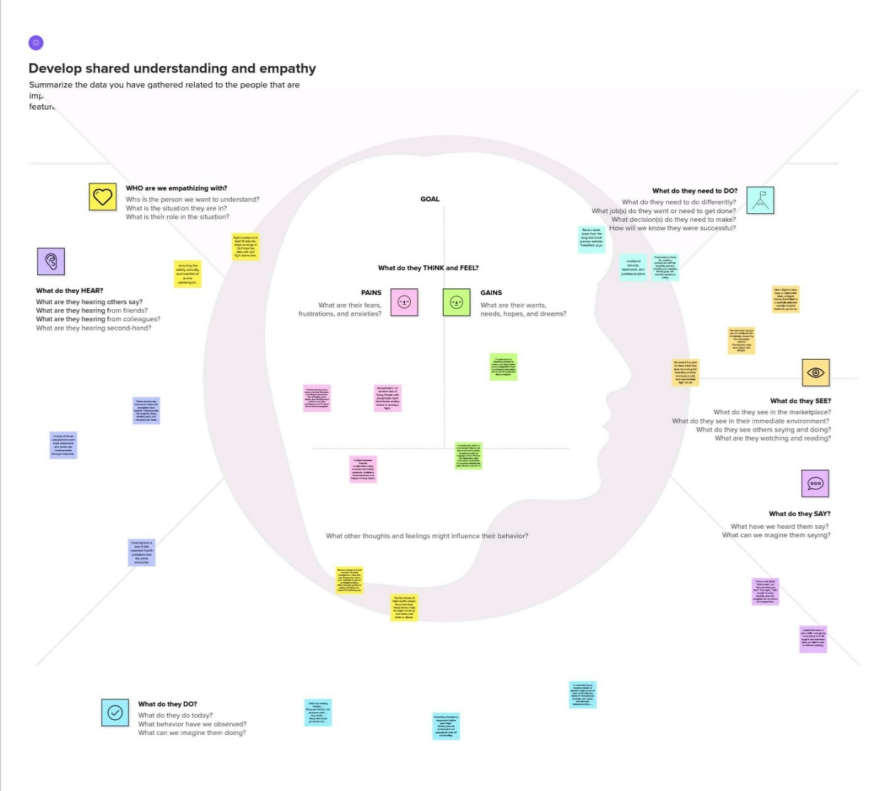

**2.2-Ideation & Brain Storming Map**

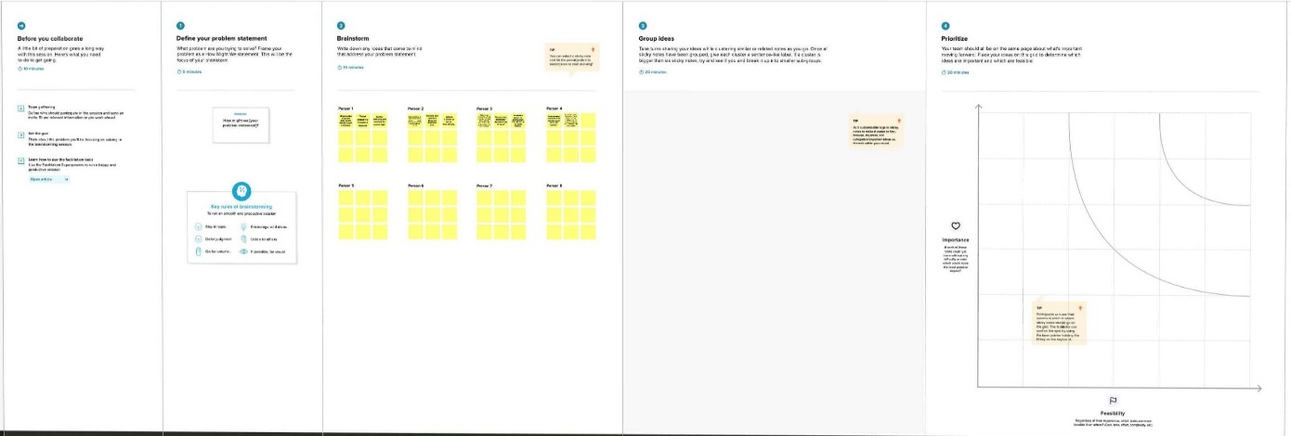

**3. RESULT**

**3.1-Data collection & Extraction from database**

For the project the data was collected from Kaggle(www.kaggle.com).Data collection is the process of gathering and measuring information on variables of interest, in an established systematic fashion that enables one to answer stated research questions, test hypotheses, and evaluate outcomes and generate insights from the data.

The dataset contains

1. Get familiar with the data

2. Explore summary statistics

3. Visualize the data

4 .Look for correlations

5 .Apply machine learning techniques

**3.2 Data Visualization**

Data visualization is the process of creating graphical representations of data in order to help people understand and explore the information. The goal of data visualization is to make complex data sets more accessible, intuitive, and easier to interpret. By using visual elements such as charts, graphs, and maps, data visualizations.

**3.2.1-Comparing aboard vs Fatalities vs ground**

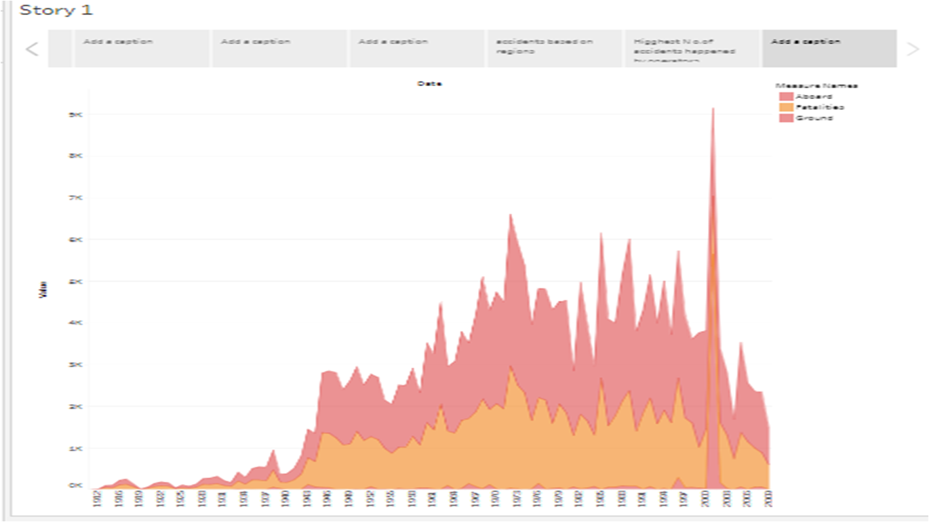

**3.2.2-Max accident based on year**

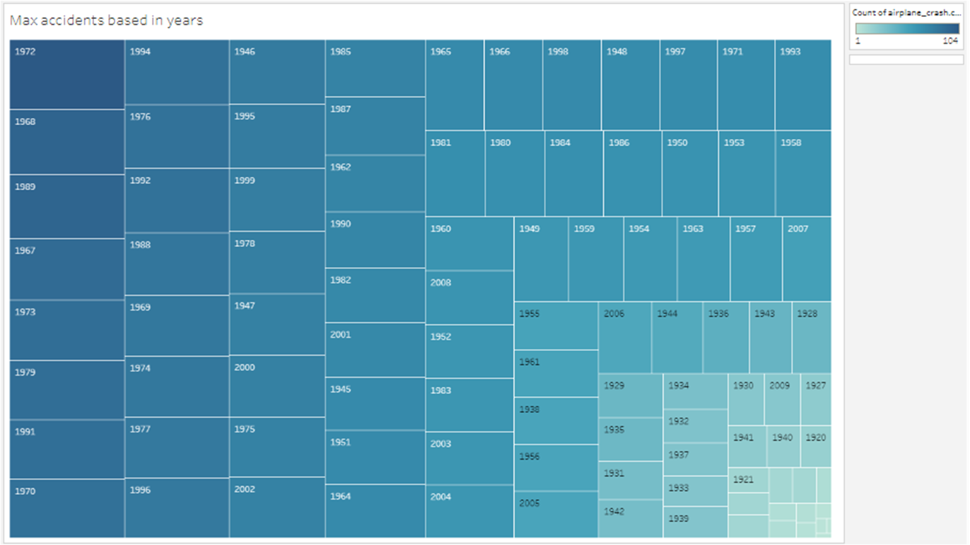

**3.3.3-Acciedent happened in 1972 based on months**

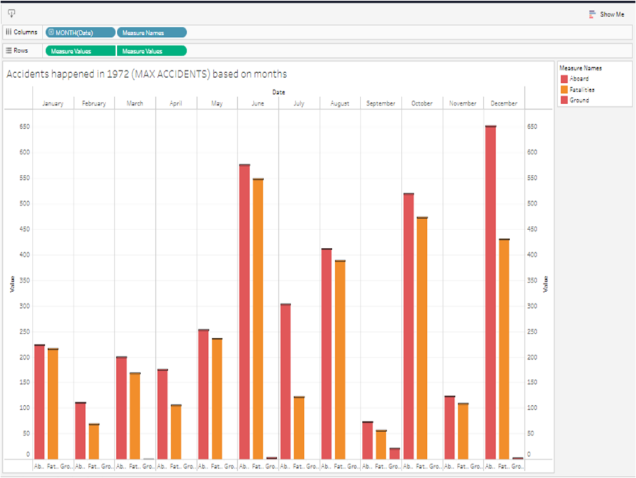

**3.2.4-Highest no of accidents happened by operators**

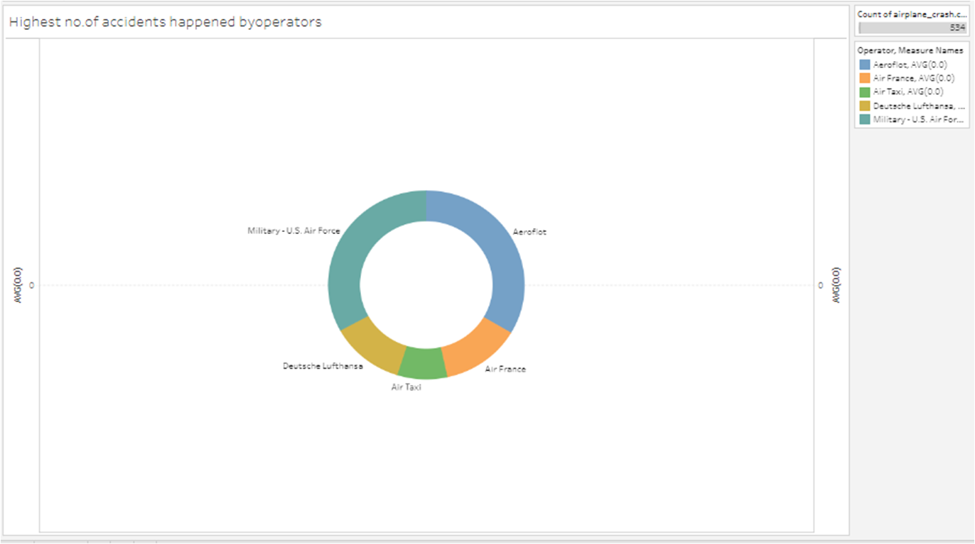

**3.2.5-Top 10 locations which had more accidents**

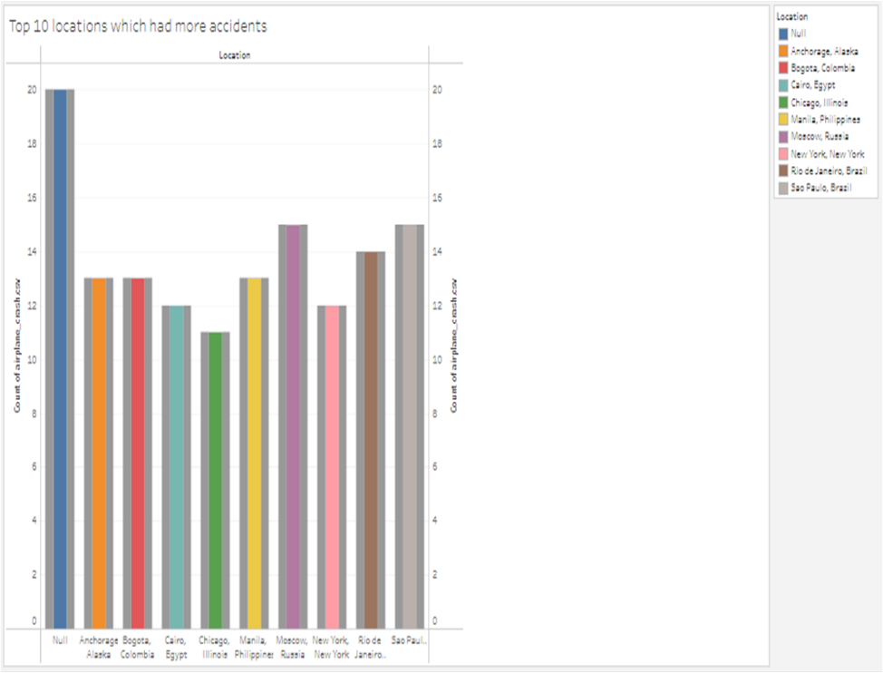

**3.2.6-Top3 flight which have max accident history**

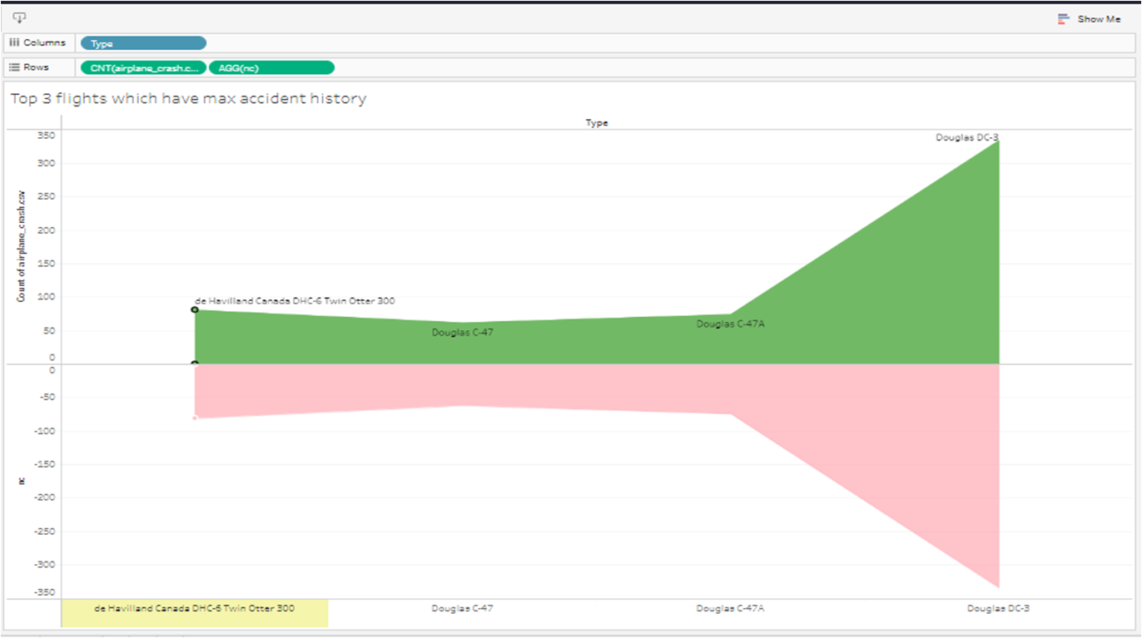

**3.2.7-Accidents based on regions**

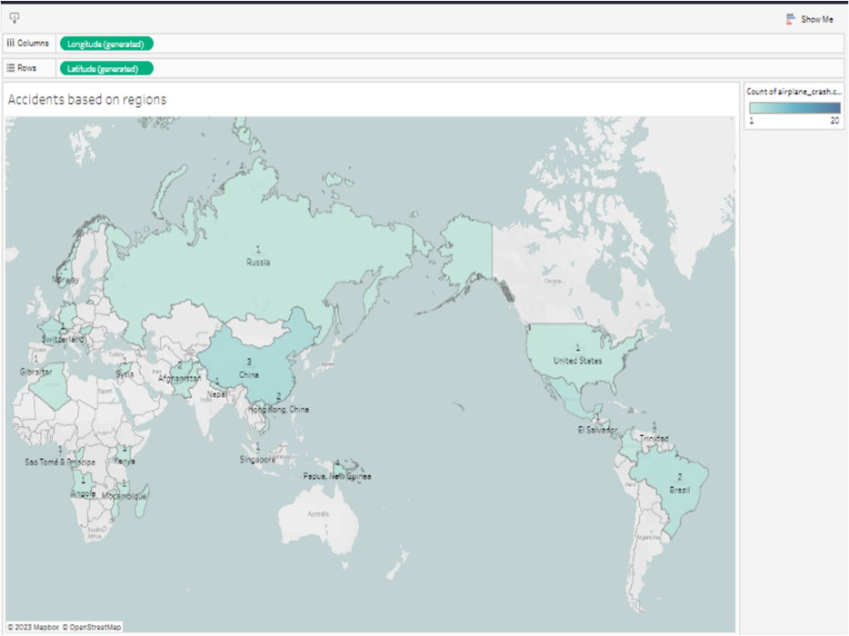

**3.3 Dashboard**

A dashboard is a graphical user interface (GUI) that displays information and data in an organized, easy-to-read format. Dashboards are often used to provide real-time monitoring and analysis of data, and are typically designed for a specific purpose or use case.

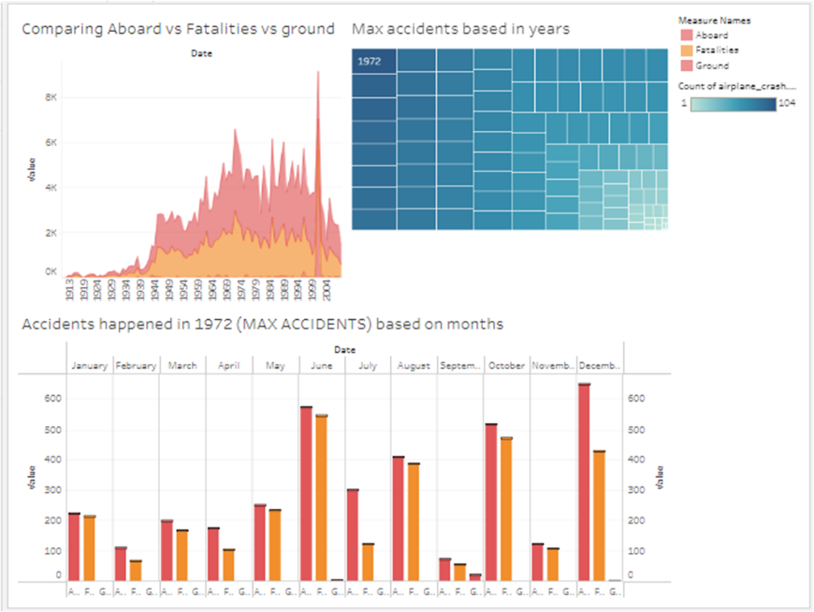

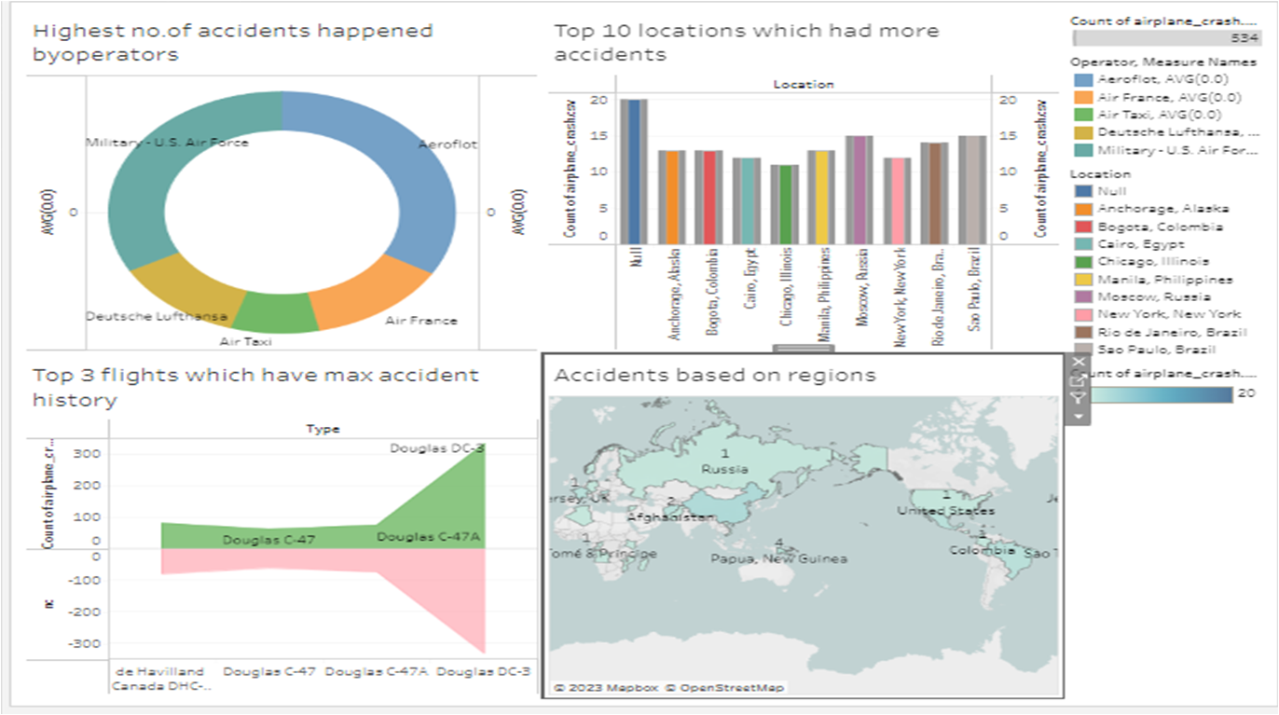**3.4 Story**





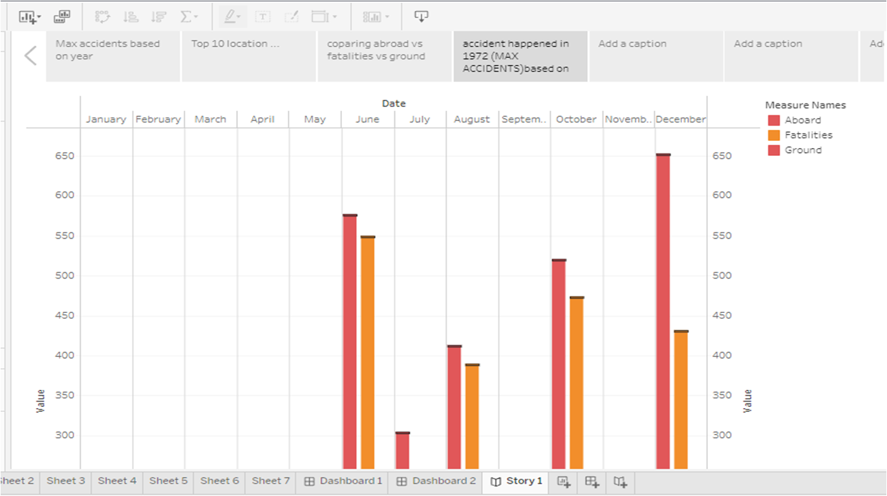

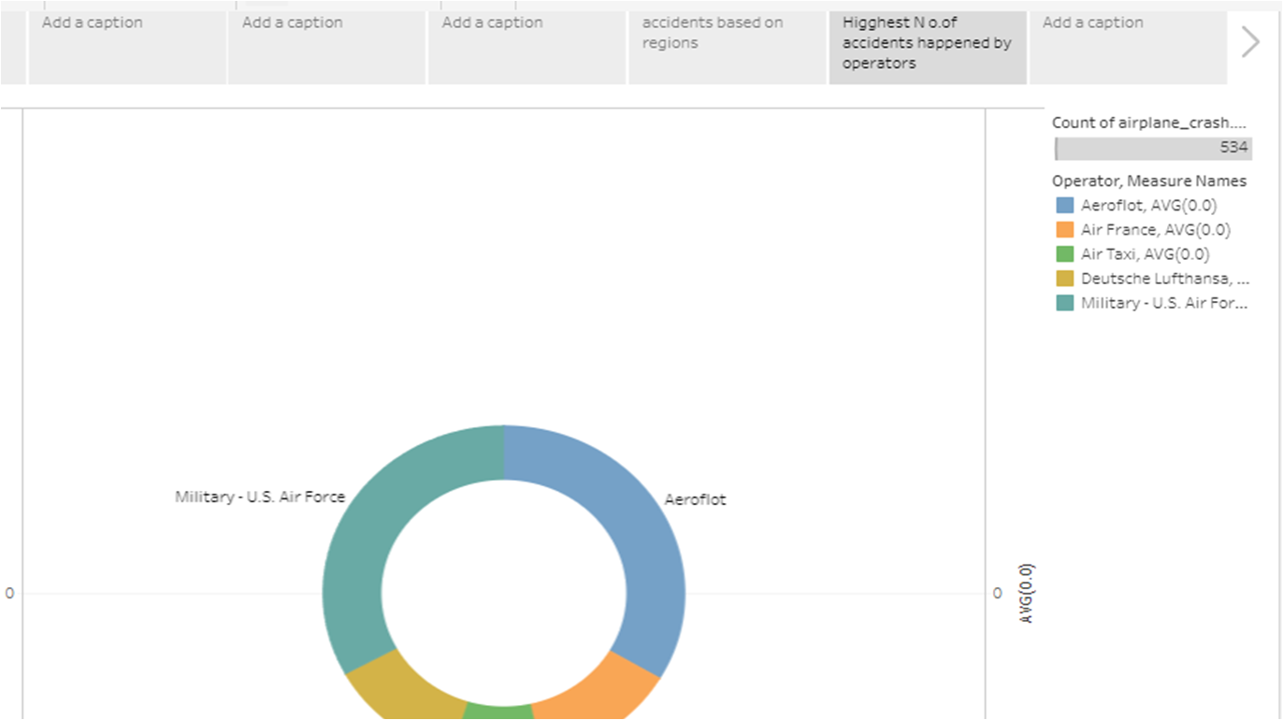

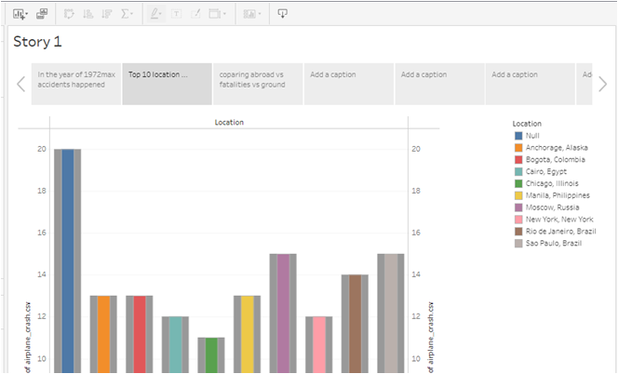

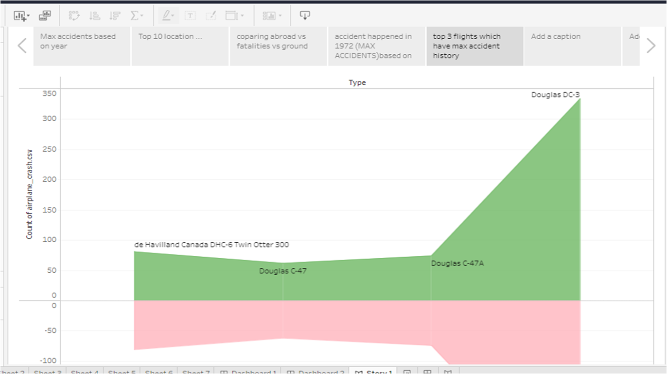

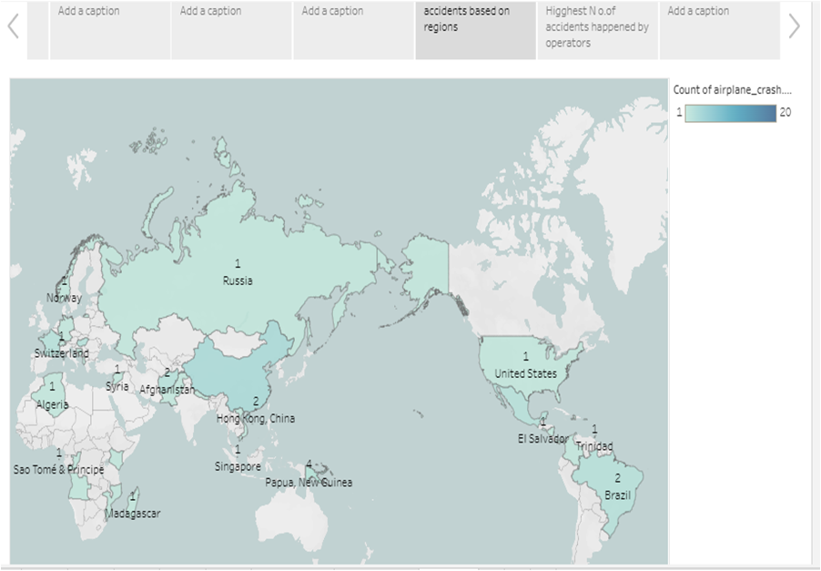

**4. ADVANTAGES & DISADVANTAGES**

**Advantage:**

1. The main benefits are focused on the speed of the service, as well as reliability for delivery.
2. It can also be useful in cases where there is no space or equipment in maritime and in this way the client can be given a solution.
3. Provides valuable insights into the causes of airplane crashes, which can inform future safety measures and prevent similar incidents from occurring in the future.
4. The most convenient option, especially when traveling long distances. It can save you time and hassle, and get you where you need to go with minimal fuss.

**Disadvantages:**

* 1. It Can Be Expensive Depending On The Route And Season.
  2. Flying can be expensive, stressful and detrimental to the environment.
  3. Can lead to increased scrutiny and negative publicity for airlines and other industry stakeholders.
  4. Can be emotionally difficult for those involved in the analysis.

**5.APPLICATION**

**Investigation:**

The gathering of evidence and analysis of data to determine the cause(s) of the crash, including technical, operational, and human factors.

**Recommendations:**

Based on the findings of the investigation, recommendations can be made to improve aviation safety, including changes to aircraft design, maintenance, crew training, and regulatory oversight.

**Implementation:**

The adoption of recommended changes, either voluntarily by industry stakeholders or through regulatory action.

**Follow-up:**

Monitoring of the effectiveness of implemented changes and ongoing evaluation of aviation safety practices.

**6.CONCLUSION:**

* The constant maintenance and repair of aircraft may seem like a trivial job but they can prove to be fatal if not done properly.
* A missing screw can jeopardize the whole aircraft.
* Lack of lubrication costed 88 lives, these are lessons the aviation industry learnt the hard way.
* Improving aviation safety and preventing tragic incidents from occurring in the future.
* While conducting a comprehensive crash analysis can be a challenging and emotional process and experts in the aviation of safety.

**7.FUTURE SCOPE:**

The comprehensive crash analysis to fully understand the task at hand, stakeholders will need background knowledge on both the company and the project. Make the scope of work clear. Include branding. A recent report suggested that hydrogen-powered planes could enter the market and those planes could carry hundreds more passengers per flight than traditional planes, with a cleaner energy source. Additionally there will be more emphasis on training pilots to resend better to emergencies and unexpected situations.

**8.WEB INTEGRATION**

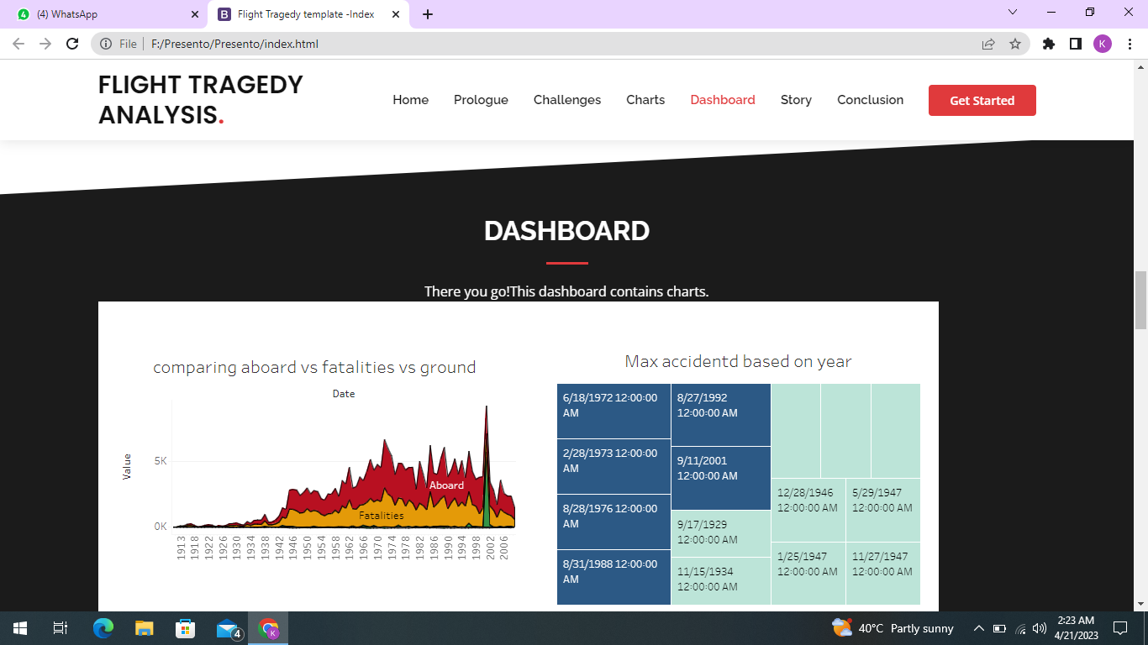

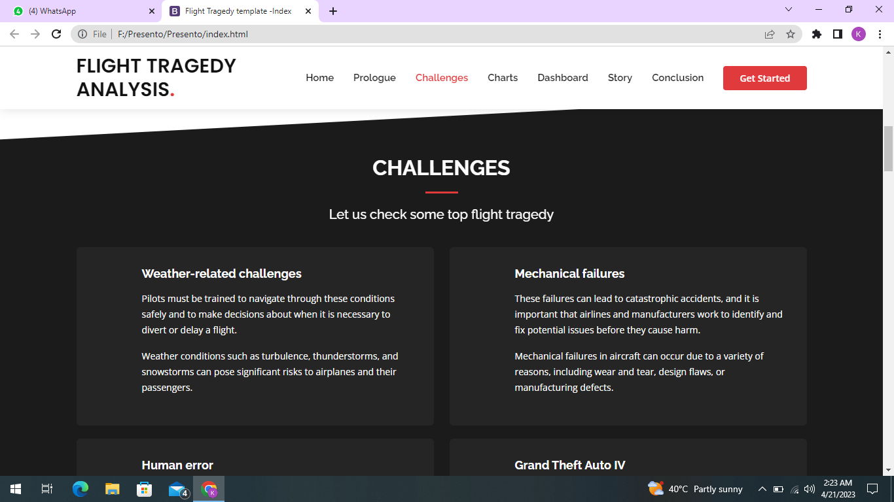

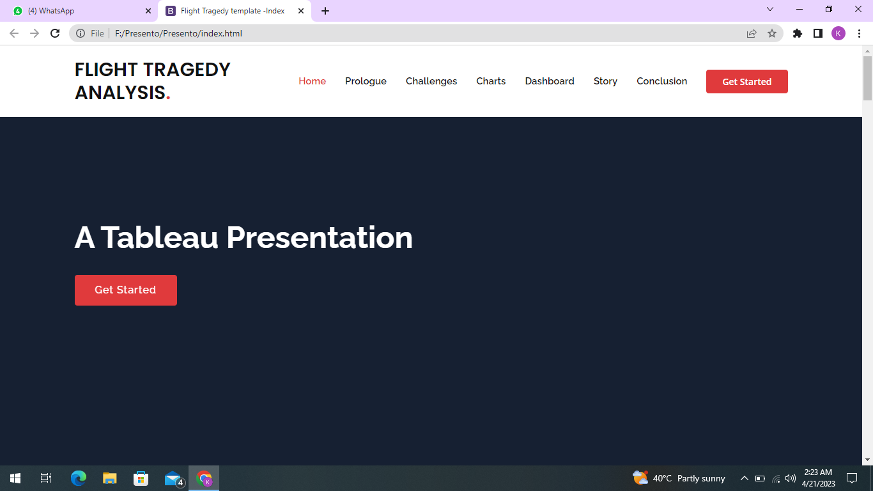

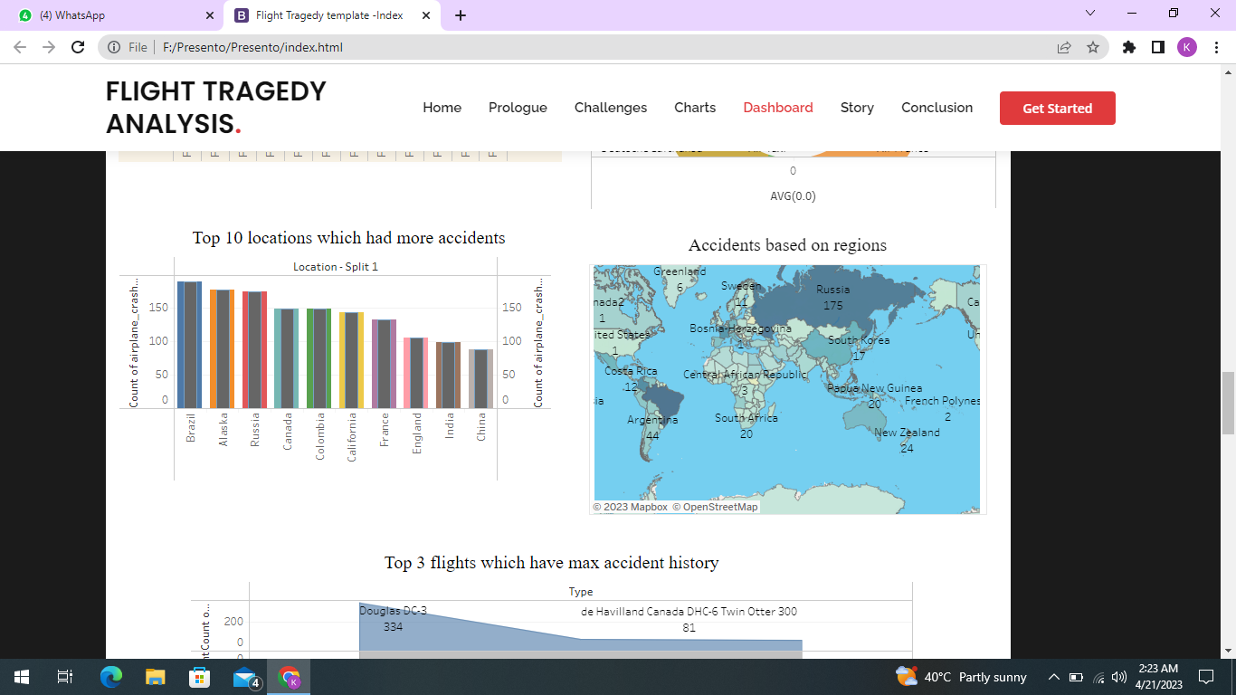

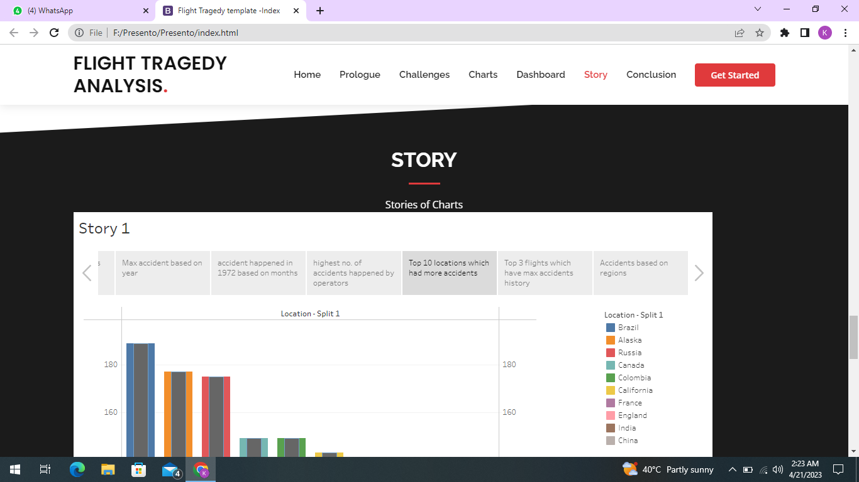

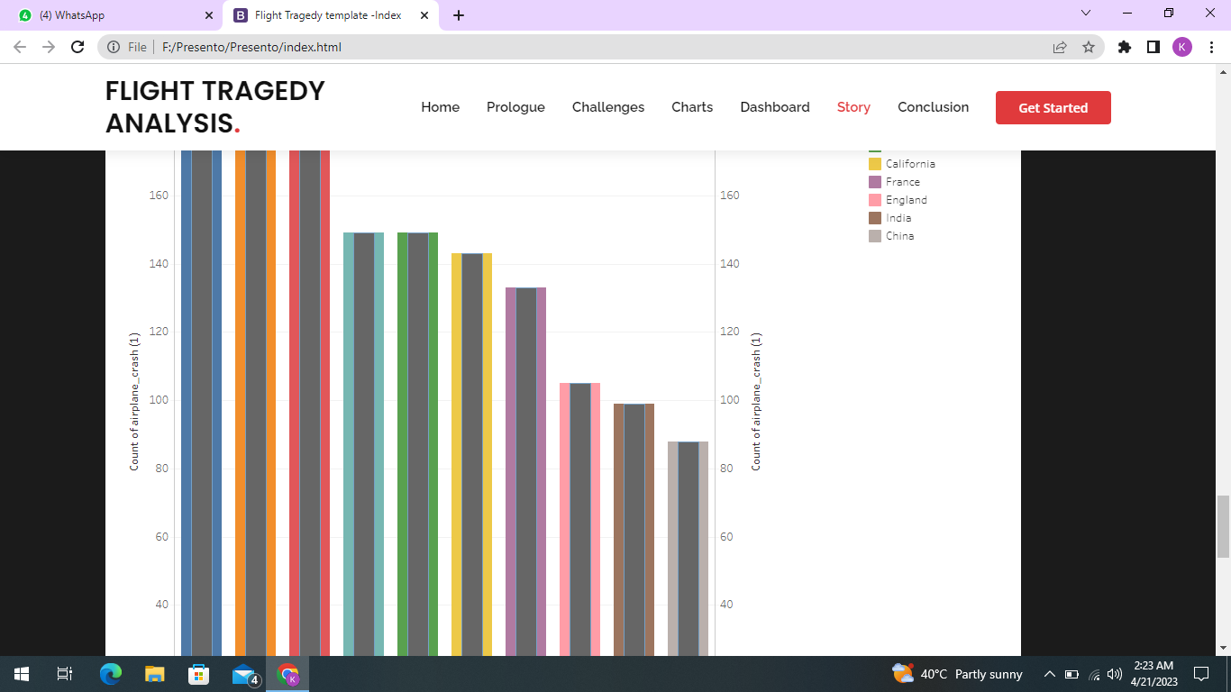

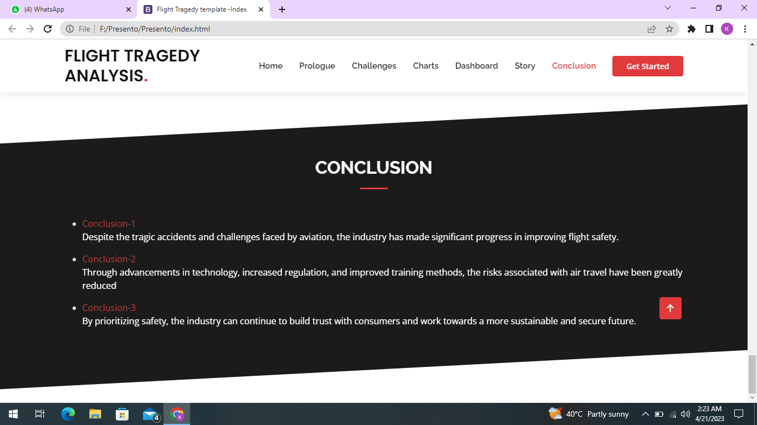

**9.APPENTIX**

Html source code:

<!DOCTYPE html>

<html lang="en">

<head>

<meta charset="utf-8">

<meta content="width=device-width, initial-scale=1.0" name="viewport">

<title>Tragedy of flight- Index</title>

<meta content="" name="description">

<meta content="" name="keywords">

<!-- Favicons -->

<link href="assets/img/favicon.png" rel="icon">

<link href="assets/img/apple-touch-icon.png" rel="apple-touch-icon">

<!-- Google Fonts -->

<link href="https://fonts.googleapis.com/css?family=Open+Sans:300,300i,400,400i,600,600i,700,700i|Jost:300,300i,400,400i,500,500i,600,600i,700,700i|Poppins:300,300i,400,400i,500,500i,600,600i,700,700i" rel="stylesheet">

<!-- Vendor CSS Files -->

<link href="assets/vendor/aos/aos.css" rel="stylesheet">

<link href="assets/vendor/bootstrap/css/bootstrap.min.css" rel="stylesheet">

<link href="assets/vendor/bootstrap-icons/bootstrap-icons.css" rel="stylesheet">

<link href="assets/vendor/boxicons/css/boxicons.min.css" rel="stylesheet">

<link href="assets/vendor/glightbox/css/glightbox.min.css" rel="stylesheet">

<link href="assets/vendor/remixicon/remixicon.css" rel="stylesheet">

<link href="assets/vendor/swiper/swiper-bundle.min.css" rel="stylesheet">

<!-- Template Main CSS File -->

<link href="assets/css/style.css" rel="stylesheet">

<!-- =======================================================

* Template Name: Arsha

* Updated: Mar 10 2023 with Bootstrap v5.2.3

* Template URL: https://bootstrapmade.com/arsha-free-bootstrap-html-template-corporate/

* Author: BootstrapMade.com

* License: https://bootstrapmade.com/license/

======================================================== -->

</head>

<body>

<!-- ======= Header ======= -->

<header id="header" class="fixed-top ">

<div class="container d-flex align-items-center">

<h1 class="logo me-auto"><a href="index.html">SHPVIBE</a></h1>

<!-- Uncomment below if you prefer to use an image logo -->

<!-- <a href="index.html" class="logo me-auto"><img src="assets/img/logo.png" alt="" class="img-fluid"></a>-->

<nav id="navbar" class="navbar">

<ul>

<li><a class="nav-link scrollto active" href="#hero">Home</a></li>

<li><a class="nav-link scrollto" href="#about">About</a></li>

<li><a class="nav-link scrollto" href="#services">Dashboard</a></li>

<li><a class="nav-link scrollto" href="#portfolio">Story</a></li>

<li><a class="nav-link scrollto" href="#contact">Contact</a></li>

<li><a class="getstarted scrollto" href="#about">Get Started</a></li>

</ul>

<i class="bi bi-list mobile-nav-toggle"></i>

</nav><!-- .navbar -->

</div>

</header><!-- End Header -->

<!-- ======= Hero Section ======= -->

<section id="hero" class="d-flex align-items-center">

<div class="container">

<div class="row">

<div class="col-lg-6 d-flex flex-column justify-content-center pt-4 pt-lg-0 order-2 order-lg-1" data-aos="fade-up" data-aos-delay="200">

<h1>Airplane Crash Analysis</h1>

<h2>Airplane Crashes and Fatalities since 1908</h2>

<div class="d-flex justify-content-center justify-content-lg-start">

<a href="#about" class="btn-get-started scrollto">Get Started</a>

<a href="https://www.youtube.com/watch?v=jDDaplaOz7Q" class="glightbox btn-watch-video"><i class="bi bi-play-circle"></i><span>Watch Video</span></a>

</div>

</div>

<div class="col-lg-6 order-1 order-lg-2 hero-img" data-aos="zoom-in" data-aos-delay="200">

<img src="assets/img/hero-img.png" class="img-fluid animated" alt="">

</div>

</div>

</div>

</section><!-- End Hero -->

<main id="main">

<!-- ======= Clients Section ======= -->

<section id="clients" class="clients section-bg">

<div class="container">

<div class="row" data-aos="zoom-in">

<div class="col-lg-2 col-md-4 col-6 d-flex align-items-center justify-content-center">

<img src="assets/img/clients/client-1.png" class="img-fluid" alt="">

</div>

<div class="col-lg-2 col-md-4 col-6 d-flex align-items-center justify-content-center">

<img src="assets/img/clients/client-2.png" class="img-fluid" alt="">

</div>

<div class="col-lg-2 col-md-4 col-6 d-flex align-items-center justify-content-center">

<img src="assets/img/clients/client-3.png" class="img-fluid" alt="">

</div>

<div class="col-lg-2 col-md-4 col-6 d-flex align-items-center justify-content-center">

<img src="assets/img/clients/client-4.png" class="img-fluid" alt="">

</div>

<div class="col-lg-2 col-md-4 col-6 d-flex align-items-center justify-content-center">

<img src="assets/img/clients/client-5.png" class="img-fluid" alt="">

</div>

<div class="col-lg-2 col-md-4 col-6 d-flex align-items-center justify-content-center">

<img src="assets/img/clients/client-6.png" class="img-fluid" alt="">

</div>

</div>

</div>

</section><!-- End Cliens Section -->

<!-- ======= About Us Section ======= -->

<section id="about" class="about">

<div class="container" data-aos="fade-up">

<div class="section-title">

<h2>About Us</h2>

</div>

<div class="row content">

<div class="col-lg-6">

<p>

Lorem ipsum dolor sit amet, consectetur adipiscing elit, sed do eiusmod tempor incididunt ut labore et dolore

magna aliqua.

</p>

<ul>

<li><i class="ri-check-double-line"></i> Ullamco laboris nisi ut aliquip ex ea commodo consequat</li>

<li><i class="ri-check-double-line"></i> Duis aute irure dolor in reprehenderit in voluptate velit</li>

<li><i class="ri-check-double-line"></i> Ullamco laboris nisi ut aliquip ex ea commodo consequat</li>

</ul>

</div>

<div class="col-lg-6 pt-4 pt-lg-0">

<p>

Ullamco laboris nisi ut aliquip ex ea commodo consequat. Duis aute irure dolor in reprehenderit in voluptate

velit esse cillum dolore eu fugiat nulla pariatur. Excepteur sint occaecat cupidatat non proident, sunt in

culpa qui officia deserunt mollit anim id est laborum.

</p>

<a href="#" class="btn-learn-more">Learn More</a>

</div>

</div>

</div>

</section><!-- End About Us Section -->

<!-- ======= Why Us Section ======= -->

<section id="why-us" class="why-us section-bg">

<div class="container-fluid" data-aos="fade-up">

<div class="row">

<div class="col-lg-7 d-flex flex-column justify-content-center align-items-stretch order-2 order-lg-1">

<div class="content">

<h3>Eum ipsam laborum deleniti <strong>velit pariatur architecto aut nihil</strong></h3>

<p>

Lorem ipsum dolor sit amet, consectetur adipiscing elit, sed do eiusmod tempor incididunt ut labore et dolore magna aliqua. Duis aute irure dolor in reprehenderit

</p>

</div>

<div class="accordion-list">

<ul>

<li>

<a data-bs-toggle="collapse" class="collapse" data-bs-target="#accordion-list-1"><span>01</span> Non consectetur a erat nam at lectus urna duis? <i class="bx bx-chevron-down icon-show"></i><i class="bx bx-chevron-up icon-close"></i></a>

<div id="accordion-list-1" class="collapse show" data-bs-parent=".accordion-list">

<p>

Feugiat pretium nibh ipsum consequat. Tempus iaculis urna id volutpat lacus laoreet non curabitur gravida. Venenatis lectus magna fringilla urna porttitor rhoncus dolor purus non.

</p>

</div>

</li>

<li>

<a data-bs-toggle="collapse" data-bs-target="#accordion-list-2" class="collapsed"><span>02</span> Feugiat scelerisque varius morbi enim nunc? <i class="bx bx-chevron-down icon-show"></i><i class="bx bx-chevron-up icon-close"></i></a>

<div id="accordion-list-2" class="collapse" data-bs-parent=".accordion-list">

<p>

Dolor sit amet consectetur adipiscing elit pellentesque habitant morbi. Id interdum velit laoreet id donec ultrices. Fringilla phasellus faucibus scelerisque eleifend donec pretium. Est pellentesque elit ullamcorper dignissim. Mauris ultrices eros in cursus turpis massa tincidunt dui.

</p>

</div>

</li>

<li>

<a data-bs-toggle="collapse" data-bs-target="#accordion-list-3" class="collapsed"><span>03</span> Dolor sit amet consectetur adipiscing elit? <i class="bx bx-chevron-down icon-show"></i><i class="bx bx-chevron-up icon-close"></i></a>

<div id="accordion-list-3" class="collapse" data-bs-parent=".accordion-list">

<p>

Eleifend mi in nulla posuere sollicitudin aliquam ultrices sagittis orci. Faucibus pulvinar elementum integer enim. Sem nulla pharetra diam sit amet nisl suscipit. Rutrum tellus pellentesque eu tincidunt. Lectus urna duis convallis convallis tellus. Urna molestie at elementum eu facilisis sed odio morbi quis

</p>

</div>

</li>

</ul>

</div>

</div>

<div class="col-lg-5 align-items-stretch order-1 order-lg-2 img" style='background-image: url("assets/img/hero-img.png");' data-aos="zoom-in" data-aos-delay="150">&nbsp;</div>

</div>

</div>

</section><!-- End Why Us Section -->

<!-- ======= Skills Section ======= -->

<section id="skills" class="skills">

<div class="container" data-aos="fade-up">

<div class="row">

<div class="col-lg-6 d-flex align-items-center" data-aos="fade-right" data-aos-delay="100">

<img src="assets/img/skills.png" class="img-fluid" alt="">

</div>

<div class="col-lg-6 pt-4 pt-lg-0 content" data-aos="fade-left" data-aos-delay="100">

<h3>Voluptatem dignissimos provident quasi corporis voluptates</h3>

<p class="fst-italic">

Lorem ipsum dolor sit amet, consectetur adipiscing elit, sed do eiusmod tempor incididunt ut labore et dolore

magna aliqua.

</p>

<div class="skills-content">

<div class="progress">

<span class="skill">HTML <i class="val">100%</i></span>

<div class="progress-bar-wrap">

<div class="progress-bar" role="progressbar" aria-valuenow="100" aria-valuemin="0" aria-valuemax="100"></div>

</div>

</div>

<div class="progress">

<span class="skill">CSS <i class="val">90%</i></span>

<div class="progress-bar-wrap">

<div class="progress-bar" role="progressbar" aria-valuenow="90" aria-valuemin="0" aria-valuemax="100"></div>

</div>

</div>

<div class="progress">

<span class="skill">JavaScript <i class="val">75%</i></span>

<div class="progress-bar-wrap">

<div class="progress-bar" role="progressbar" aria-valuenow="75" aria-valuemin="0" aria-valuemax="100"></div>

</div>

</div>

<div class="progress">

<span class="skill">Photoshop <i class="val">55%</i></span>

<div class="progress-bar-wrap">

<div class="progress-bar" role="progressbar" aria-valuenow="55" aria-valuemin="0" aria-valuemax="100"></div>

</div>

</div>

</div>

</div>

</div>

</div>

</section><!-- End Skills Section -->

<!-- ======= Services Section ======= -->

<section id="services" class="services section-bg">

<div class="container" data-aos="fade-up">

<div class="section-title">

<h2>Services</h2>

<p>Magnam dolores commodi suscipit. Necessitatibus eius consequatur ex aliquid fuga eum quidem. Sit sint consectetur velit. Quisquam quos quisquam cupiditate. Et nemo qui impedit suscipit alias ea. Quia fugiat sit in iste officiis commodi quidem hic quas.</p>

</div>

<div class="row">

<div class="col-xl-3 col-md-6 d-flex align-items-stretch" data-aos="zoom-in" data-aos-delay="100">

<div class="icon-box">

<div class="icon"><i class="bx bxl-dribbble"></i></div>

<h4><a href="">Lorem Ipsum</a></h4>

<p>Voluptatum deleniti atque corrupti quos dolores et quas molestias excepturi</p>

</div>

</div>

<div class="col-xl-3 col-md-6 d-flex align-items-stretch mt-4 mt-md-0" data-aos="zoom-in" data-aos-delay="200">

<div class="icon-box">

<div class="icon"><i class="bx bx-file"></i></div>

<h4><a href="">Sed ut perspici</a></h4>

<p>Duis aute irure dolor in reprehenderit in voluptate velit esse cillum dolore</p>

</div>

</div>

<div class="col-xl-3 col-md-6 d-flex align-items-stretch mt-4 mt-xl-0" data-aos="zoom-in" data-aos-delay="300">

<div class="icon-box">

<div class="icon"><i class="bx bx-tachometer"></i></div>

<h4><a href="">Magni Dolores</a></h4>

<p>Excepteur sint occaecat cupidatat non proident, sunt in culpa qui officia</p>

</div>

</div>

<div class="col-xl-3 col-md-6 d-flex align-items-stretch mt-4 mt-xl-0" data-aos="zoom-in" data-aos-delay="400">

<div class="icon-box">

<div class="icon"><i class="bx bx-layer"></i></div>

<h4><a href="">Nemo Enim</a></h4>

<p>At vero eos et accusamus et iusto odio dignissimos ducimus qui blanditiis</p>

</div>

</div>

</div>

</div>

</section><!-- End Services Section -->

<!-- ======= Cta Section ======= -->

<section id="cta" class="cta">

<div class="container" data-aos="zoom-in">

<div class="row">

<div class="col-lg-9 text-center text-lg-start">

<h3>Call To Action</h3>

<p> Duis aute irure dolor in reprehenderit in voluptate velit esse cillum dolore eu fugiat nulla pariatur. Excepteur sint occaecat cupidatat non proident, sunt in culpa qui officia deserunt mollit anim id est laborum.</p>

</div>

<div class="col-lg-3 cta-btn-container text-center">

<a class="cta-btn align-middle" href="#">Call To Action</a>

</div>

</div>

</div>

</section><!-- End Cta Section -->

<!-- ======= Portfolio Section ======= -->

<section id="portfolio" class="portfolio">

<div class="container" data-aos="fade-up">

<div class="section-title">

<h2>Portfolio</h2>

<p>Magnam dolores commodi suscipit. Necessitatibus eius consequatur ex aliquid fuga eum quidem. Sit sint consectetur velit. Quisquam quos quisquam cupiditate. Et nemo qui impedit suscipit alias ea. Quia fugiat sit in iste officiis commodi quidem hic quas.</p>

</div>

<ul id="portfolio-flters" class="d-flex justify-content-center" data-aos="fade-up" data-aos-delay="100">

<li data-filter="*" class="filter-active">All</li>

<li data-filter=".filter-app">App</li>

<li data-filter=".filter-card">Card</li>

<li data-filter=".filter-web">Web</li>

</ul>

<div class="row portfolio-container" data-aos="fade-up" data-aos-delay="200">

<div class="col-lg-4 col-md-6 portfolio-item filter-app">

<div class="portfolio-img"><img src="assets/img/portfolio/portfolio-1.jpg" class="img-fluid" alt=""></div>

<div class="portfolio-info">

<h4>App 1</h4>

<p>App</p>

<a href="assets/img/portfolio/portfolio-1.jpg" data-gallery="portfolioGallery" class="portfolio-lightbox preview-link" title="App 1"><i class="bx bx-plus"></i></a>

<a href="portfolio-details.html" class="details-link" title="More Details"><i class="bx bx-link"></i></a>

</div>

</div>

<div class="col-lg-4 col-md-6 portfolio-item filter-web">

<div class="portfolio-img"><img src="assets/img/portfolio/portfolio-2.jpg" class="img-fluid" alt=""></div>

<div class="portfolio-info">

<h4>Web 3</h4>

<p>Web</p>

<a href="assets/img/portfolio/portfolio-2.jpg" data-gallery="portfolioGallery" class="portfolio-lightbox preview-link" title="Web 3"><i class="bx bx-plus"></i></a>

<a href="portfolio-details.html" class="details-link" title="More Details"><i class="bx bx-link"></i></a>

</div>

</div>

<div class="col-lg-4 col-md-6 portfolio-item filter-app">

<div class="portfolio-img"><img src="assets/img/portfolio/portfolio-3.jpg" class="img-fluid" alt=""></div>

<div class="portfolio-info">

<h4>App 2</h4>

<p>App</p>

<a href="assets/img/portfolio/portfolio-3.jpg" data-gallery="portfolioGallery" class="portfolio-lightbox preview-link" title="App 2"><i class="bx bx-plus"></i></a>

<a href="portfolio-details.html" class="details-link" title="More Details"><i class="bx bx-link"></i></a>

</div>

</div>

<div class="col-lg-4 col-md-6 portfolio-item filter-card">

<div class="portfolio-img"><img src="assets/img/portfolio/portfolio-4.jpg" class="img-fluid" alt=""></div>

<div class="portfolio-info">

<h4>Card 2</h4>

<p>Card</p>

<a href="assets/img/portfolio/portfolio-4.jpg" data-gallery="portfolioGallery" class="portfolio-lightbox preview-link" title="Card 2"><i class="bx bx-plus"></i></a>

<a href="portfolio-details.html" class="details-link" title="More Details"><i class="bx bx-link"></i></a>

</div>

</div>

<div class="col-lg-4 col-md-6 portfolio-item filter-web">

<div class="portfolio-img"><img src="assets/img/portfolio/portfolio-5.jpg" class="img-fluid" alt=""></div>

<div class="portfolio-info">

<h4>Web 2</h4>

<p>Web</p>

<a href="assets/img/portfolio/portfolio-5.jpg" data-gallery="portfolioGallery" class="portfolio-lightbox preview-link" title="Web 2"><i class="bx bx-plus"></i></a>

<a href="portfolio-details.html" class="details-link" title="More Details"><i class="bx bx-link"></i></a>

</div>

</div>

<div class="col-lg-4 col-md-6 portfolio-item filter-app">

<div class="portfolio-img"><img src="assets/img/portfolio/portfolio-6.jpg" class="img-fluid" alt=""></div>

<div class="portfolio-info">

<h4>App 3</h4>

<p>App</p>

<a href="assets/img/portfolio/portfolio-6.jpg" data-gallery="portfolioGallery" class="portfolio-lightbox preview-link" title="App 3"><i class="bx bx-plus"></i></a>

<a href="portfolio-details.html" class="details-link" title="More Details"><i class="bx bx-link"></i></a>

</div>

</div>

<div class="col-lg-4 col-md-6 portfolio-item filter-card">

<div class="portfolio-img"><img src="assets/img/portfolio/portfolio-7.jpg" class="img-fluid" alt=""></div>

<div class="portfolio-info">

<h4>Card 1</h4>

<p>Card</p>

<a href="assets/img/portfolio/portfolio-7.jpg" data-gallery="portfolioGallery" class="portfolio-lightbox preview-link" title="Card 1"><i class="bx bx-plus"></i></a>

<a href="portfolio-details.html" class="details-link" title="More Details"><i class="bx bx-link"></i></a>

</div>

</div>

<div class="col-lg-4 col-md-6 portfolio-item filter-card">

<div class="portfolio-img"><img src="assets/img/portfolio/portfolio-8.jpg" class="img-fluid" alt=""></div>

<div class="portfolio-info">

<h4>Card 3</h4>

<p>Card</p>

<a href="assets/img/portfolio/portfolio-8.jpg" data-gallery="portfolioGallery" class="portfolio-lightbox preview-link" title="Card 3"><i class="bx bx-plus"></i></a>

<a href="portfolio-details.html" class="details-link" title="More Details"><i class="bx bx-link"></i></a>

</div>

</div>

<div class="col-lg-4 col-md-6 portfolio-item filter-web">

<div class="portfolio-img"><img src="assets/img/portfolio/portfolio-9.jpg" class="img-fluid" alt=""></div>

<div class="portfolio-info">

<h4>Web 3</h4>

<p>Web</p>

<a href="assets/img/portfolio/portfolio-9.jpg" data-gallery="portfolioGallery" class="portfolio-lightbox preview-link" title="Web 3"><i class="bx bx-plus"></i></a>

<a href="portfolio-details.html" class="details-link" title="More Details"><i class="bx bx-link"></i></a>

</div>

</div>

</div>

</div>

</section><!-- End Portfolio Section -->

<!-- ======= Team Section ======= -->

<section id="team" class="team section-bg">

<div class="container" data-aos="fade-up">

<div class="section-title">

<h2>Team</h2>

<p>Magnam dolores commodi suscipit. Necessitatibus eius consequatur ex aliquid fuga eum quidem. Sit sint consectetur velit. Quisquam quos quisquam cupiditate. Et nemo qui impedit suscipit alias ea. Quia fugiat sit in iste officiis commodi quidem hic quas.</p>

</div>

<div class="row">

<div class="col-lg-6" data-aos="zoom-in" data-aos-delay="100">

<div class="member d-flex align-items-start">

<div class="pic"><img src="assets/img/team/team-1.jpg" class="img-fluid" alt=""></div>

<div class="member-info">

<h4>Walter White</h4>

<span>Chief Executive Officer</span>

<p>Explicabo voluptatem mollitia et repellat qui dolorum quasi</p>

<div class="social">

<a href=""><i class="ri-twitter-fill"></i></a>

<a href=""><i class="ri-facebook-fill"></i></a>

<a href=""><i class="ri-instagram-fill"></i></a>

<a href=""> <i class="ri-linkedin-box-fill"></i> </a>

</div>

</div>

</div>

</div>

<div class="col-lg-6 mt-4 mt-lg-0" data-aos="zoom-in" data-aos-delay="200">

<div class="member d-flex align-items-start">

<div class="pic"><img src="assets/img/team/team-2.jpg" class="img-fluid" alt=""></div>

<div class="member-info">

<h4>Sarah Jhonson</h4>

<span>Product Manager</span>

<p>Aut maiores voluptates amet et quis praesentium qui senda para</p>

<div class="social">

<a href=""><i class="ri-twitter-fill"></i></a>

<a href=""><i class="ri-facebook-fill"></i></a>

<a href=""><i class="ri-instagram-fill"></i></a>

<a href=""> <i class="ri-linkedin-box-fill"></i> </a>

</div>

</div>

</div>

</div>

<div class="col-lg-6 mt-4" data-aos="zoom-in" data-aos-delay="300">

<div class="member d-flex align-items-start">

<div class="pic"><img src="assets/img/team/team-3.jpg" class="img-fluid" alt=""></div>

<div class="member-info">

<h4>William Anderson</h4>

<span>CTO</span>

<p>Quisquam facilis cum velit laborum corrupti fuga rerum quia</p>

<div class="social">

<a href=""><i class="ri-twitter-fill"></i></a>

<a href=""><i class="ri-facebook-fill"></i></a>

<a href=""><i class="ri-instagram-fill"></i></a>

<a href=""> <i class="ri-linkedin-box-fill"></i> </a>

</div>

</div>

</div>

</div>

<div class="col-lg-6 mt-4" data-aos="zoom-in" data-aos-delay="400">

<div class="member d-flex align-items-start">

<div class="pic"><img src="assets/img/team/team-4.jpg" class="img-fluid" alt=""></div>

<div class="member-info">

<h4>Amanda Jepson</h4>

<span>Accountant</span>

<p>Dolorum tempora officiis odit laborum officiis et et accusamus</p>

<div class="social">

<a href=""><i class="ri-twitter-fill"></i></a>

<a href=""><i class="ri-facebook-fill"></i></a>

<a href=""><i class="ri-instagram-fill"></i></a>

<a href=""> <i class="ri-linkedin-box-fill"></i> </a>

</div>

</div>

</div>

</div>

</div>

</div>

</section><!-- End Team Section -->

<!-- ======= Pricing Section ======= -->

<section id="pricing" class="pricing">

<div class="container" data-aos="fade-up">

<div class="section-title">

<h2>Pricing</h2>

<p>Magnam dolores commodi suscipit. Necessitatibus eius consequatur ex aliquid fuga eum quidem. Sit sint consectetur velit. Quisquam quos quisquam cupiditate. Et nemo qui impedit suscipit alias ea. Quia fugiat sit in iste officiis commodi quidem hic quas.</p>

</div>

<div class="row">

<div class="col-lg-4" data-aos="fade-up" data-aos-delay="100">

<div class="box">

<h3>Free Plan</h3>

<h4><sup>$</sup>0<span>per month</span></h4>

<ul>

<li><i class="bx bx-check"></i> Quam adipiscing vitae proin</li>

<li><i class="bx bx-check"></i> Nec feugiat nisl pretium</li>

<li><i class="bx bx-check"></i> Nulla at volutpat diam uteera</li>

<li class="na"><i class="bx bx-x"></i> <span>Pharetra massa massa ultricies</span></li>

<li class="na"><i class="bx bx-x"></i> <span>Massa ultricies mi quis hendrerit</span></li>

</ul>

<a href="#" class="buy-btn">Get Started</a>

</div>

</div>

<div class="col-lg-4 mt-4 mt-lg-0" data-aos="fade-up" data-aos-delay="200">

<div class="box featured">

<h3>Business Plan</h3>

<h4><sup>$</sup>29<span>per month</span></h4>

<ul>

<li><i class="bx bx-check"></i> Quam adipiscing vitae proin</li>

<li><i class="bx bx-check"></i> Nec feugiat nisl pretium</li>

<li><i class="bx bx-check"></i> Nulla at volutpat diam uteera</li>

<li><i class="bx bx-check"></i> Pharetra massa massa ultricies</li>

<li><i class="bx bx-check"></i> Massa ultricies mi quis hendrerit</li>

</ul>

<a href="#" class="buy-btn">Get Started</a>

</div>

</div>

<div class="col-lg-4 mt-4 mt-lg-0" data-aos="fade-up" data-aos-delay="300">

<div class="box">

<h3>Developer Plan</h3>

<h4><sup>$</sup>49<span>per month</span></h4>

<ul>

<li><i class="bx bx-check"></i> Quam adipiscing vitae proin</li>

<li><i class="bx bx-check"></i> Nec feugiat nisl pretium</li>

<li><i class="bx bx-check"></i> Nulla at volutpat diam uteera</li>

<li><i class="bx bx-check"></i> Pharetra massa massa ultricies</li>

<li><i class="bx bx-check"></i> Massa ultricies mi quis hendrerit</li>

</ul>

<a href="#" class="buy-btn">Get Started</a>

</div>

</div>

</div>

</div>

</section><!-- End Pricing Section -->

<!-- ======= Frequently Asked Questions Section ======= -->

<section id="faq" class="faq section-bg">

<div class="container" data-aos="fade-up">

<div class="section-title">

<h2>Frequently Asked Questions</h2>

<p>Magnam dolores commodi suscipit. Necessitatibus eius consequatur ex aliquid fuga eum quidem. Sit sint consectetur velit. Quisquam quos quisquam cupiditate. Et nemo qui impedit suscipit alias ea. Quia fugiat sit in iste officiis commodi quidem hic quas.</p>

</div>

<div class="faq-list">

<ul>

<li data-aos="fade-up" data-aos-delay="100">

<i class="bx bx-help-circle icon-help"></i> <a data-bs-toggle="collapse" class="collapse" data-bs-target="#faq-list-1">Non consectetur a erat nam at lectus urna duis? <i class="bx bx-chevron-down icon-show"></i><i class="bx bx-chevron-up icon-close"></i></a>

<div id="faq-list-1" class="collapse show" data-bs-parent=".faq-list">

<p>

Feugiat pretium nibh ipsum consequat. Tempus iaculis urna id volutpat lacus laoreet non curabitur gravida. Venenatis lectus magna fringilla urna porttitor rhoncus dolor purus non.

</p>

</div>

</li>

<li data-aos="fade-up" data-aos-delay="200">

<i class="bx bx-help-circle icon-help"></i> <a data-bs-toggle="collapse" data-bs-target="#faq-list-2" class="collapsed">Feugiat scelerisque varius morbi enim nunc? <i class="bx bx-chevron-down icon-show"></i><i class="bx bx-chevron-up icon-close"></i></a>

<div id="faq-list-2" class="collapse" data-bs-parent=".faq-list">

<p>

Dolor sit amet consectetur adipiscing elit pellentesque habitant morbi. Id interdum velit laoreet id donec ultrices. Fringilla phasellus faucibus scelerisque eleifend donec pretium. Est pellentesque elit ullamcorper dignissim. Mauris ultrices eros in cursus turpis massa tincidunt dui.

</p>

</div>

</li>

<li data-aos="fade-up" data-aos-delay="300">

<i class="bx bx-help-circle icon-help"></i> <a data-bs-toggle="collapse" data-bs-target="#faq-list-3" class="collapsed">Dolor sit amet consectetur adipiscing elit? <i class="bx bx-chevron-down icon-show"></i><i class="bx bx-chevron-up icon-close"></i></a>

<div id="faq-list-3" class="collapse" data-bs-parent=".faq-list">

<p>

Eleifend mi in nulla posuere sollicitudin aliquam ultrices sagittis orci. Faucibus pulvinar elementum integer enim. Sem nulla pharetra diam sit amet nisl suscipit. Rutrum tellus pellentesque eu tincidunt. Lectus urna duis convallis convallis tellus. Urna molestie at elementum eu facilisis sed odio morbi quis

</p>

</div>

</li>

<li data-aos="fade-up" data-aos-delay="400">

<i class="bx bx-help-circle icon-help"></i> <a data-bs-toggle="collapse" data-bs-target="#faq-list-4" class="collapsed">Tempus quam pellentesque nec nam aliquam sem et tortor consequat? <i class="bx bx-chevron-down icon-show"></i><i class="bx bx-chevron-up icon-close"></i></a>

<div id="faq-list-4" class="collapse" data-bs-parent=".faq-list">

<p>

Molestie a iaculis at erat pellentesque adipiscing commodo. Dignissim suspendisse in est ante in. Nunc vel risus commodo viverra maecenas accumsan. Sit amet nisl suscipit adipiscing bibendum est. Purus gravida quis blandit turpis cursus in.

</p>

</div>

</li>

<li data-aos="fade-up" data-aos-delay="500">

<i class="bx bx-help-circle icon-help"></i> <a data-bs-toggle="collapse" data-bs-target="#faq-list-5" class="collapsed">Tortor vitae purus faucibus ornare. Varius vel pharetra vel turpis nunc eget lorem dolor? <i class="bx bx-chevron-down icon-show"></i><i class="bx bx-chevron-up icon-close"></i></a>

<div id="faq-list-5" class="collapse" data-bs-parent=".faq-list">

<p>

Laoreet sit amet cursus sit amet dictum sit amet justo. Mauris vitae ultricies leo integer malesuada nunc vel. Tincidunt eget nullam non nisi est sit amet. Turpis nunc eget lorem dolor sed. Ut venenatis tellus in metus vulputate eu scelerisque.

</p>

</div>

</li>

</ul>

</div>

</div>

</section><!-- End Frequently Asked Questions Section -->

<!-- ======= Contact Section ======= -->

<section id="contact" class="contact">

<div class="container" data-aos="fade-up">

<div class="section-title">

<h2>Contact</h2>

<p>Magnam dolores commodi suscipit. Necessitatibus eius consequatur ex aliquid fuga eum quidem. Sit sint consectetur velit. Quisquam quos quisquam cupiditate. Et nemo qui impedit suscipit alias ea. Quia fugiat sit in iste officiis commodi quidem hic quas.</p>

</div>

<div class="row">

<div class="col-lg-5 d-flex align-items-stretch">

<div class="info">

<div class="address">

<i class="bi bi-geo-alt"></i>

<h4>Location:</h4>

<p>A108 Adam Street, New York, NY 535022</p>

</div>

<div class="email">

<i class="bi bi-envelope"></i>

<h4>Email:</h4>

<p>info@example.com</p>

</div>

<div class="phone">

<i class="bi bi-phone"></i>

<h4>Call:</h4>

<p>+1 5589 55488 55s</p>

</div>

<iframe src="https://www.google.com/maps/embed?pb=!1m14!1m8!1m3!1d12097.433213460943!2d-74.0062269!3d40.7101282!3m2!1i1024!2i768!4f13.1!3m3!1m2!1s0x0%3A0xb89d1fe6bc499443!2sDowntown+Conference+Center!5e0!3m2!1smk!2sbg!4v1539943755621" frameborder="0" style="border:0; width: 100%; height: 290px;" allowfullscreen></iframe>

</div>

</div>

<div class="col-lg-7 mt-5 mt-lg-0 d-flex align-items-stretch">

<form action="forms/contact.php" method="post" role="form" class="php-email-form">

<div class="row">

<div class="form-group col-md-6">

<label for="name">Your Name</label>

<input type="text" name="name" class="form-control" id="name" required>

</div>

<div class="form-group col-md-6">

<label for="name">Your Email</label>

<input type="email" class="form-control" name="email" id="email" required>

</div>

</div>

<div class="form-group">

<label for="name">Subject</label>

<input type="text" class="form-control" name="subject" id="subject" required>

</div>

<div class="form-group">

<label for="name">Message</label>

<textarea class="form-control" name="message" rows="10" required></textarea>

</div>

<div class="my-3">

<div class="loading">Loading</div>

<div class="error-message"></div>

<div class="sent-message">Your message has been sent. Thank you!</div>

</div>

<div class="text-center"><button type="submit">Send Message</button></div>

</form>

</div>

</div>

</div>

</section><!-- End Contact Section -->

</main><!-- End #main -->

<!-- ======= Footer ======= -->

<footer id="footer">

<div class="footer-newsletter">

<div class="container">

<div class="row justify-content-center">

<div class="col-lg-6">

<h4>Join Our Newsletter</h4>

<p>Tamen quem nulla quae legam multos aute sint culpa legam noster magna</p>

<form action="" method="post">

<input type="email" name="email"><input type="submit" value="Subscribe">

</form>

</div>

</div>

</div>

</div>

<div class="footer-top">

<div class="container">

<div class="row">

<div class="col-lg-3 col-md-6 footer-contact">

<h3>Arsha</h3>

<p>

A108 Adam Street <br>

New York, NY 535022<br>

United States <br><br>

<strong>Phone:</strong> +1 5589 55488 55<br>

<strong>Email:</strong> info@example.com<br>

</p>

</div>

<div class="col-lg-3 col-md-6 footer-links">

<h4>Useful Links</h4>

<ul>

<li><i class="bx bx-chevron-right"></i> <a href="#">Home</a></li>

<li><i class="bx bx-chevron-right"></i> <a href="#">About us</a></li>

<li><i class="bx bx-chevron-right"></i> <a href="#">Services</a></li>

<li><i class="bx bx-chevron-right"></i> <a href="#">Terms of service</a></li>

<li><i class="bx bx-chevron-right"></i> <a href="#">Privacy policy</a></li>

</ul>

</div>

<div class="col-lg-3 col-md-6 footer-links">

<h4>Our Services</h4>

<ul>

<li><i class="bx bx-chevron-right"></i> <a href="#">Web Design</a></li>

<li><i class="bx bx-chevron-right"></i> <a href="#">Web Development</a></li>

<li><i class="bx bx-chevron-right"></i> <a href="#">Product Management</a></li>

<li><i class="bx bx-chevron-right"></i> <a href="#">Marketing</a></li>

<li><i class="bx bx-chevron-right"></i> <a href="#">Graphic Design</a></li>

</ul>

</div>

<div class="col-lg-3 col-md-6 footer-links">

<h4>Our Social Networks</h4>

<p>Cras fermentum odio eu feugiat lide par naso tierra videa magna derita valies</p>

<div class="social-links mt-3">

<a href="#" class="twitter"><i class="bx bxl-twitter"></i></a>

<a href="#" class="facebook"><i class="bx bxl-facebook"></i></a>

<a href="#" class="instagram"><i class="bx bxl-instagram"></i></a>

<a href="#" class="google-plus"><i class="bx bxl-skype"></i></a>

<a href="#" class="linkedin"><i class="bx bxl-linkedin"></i></a>

</div>

</div>

</div>

</div>

</div>

<div class="container footer-bottom clearfix">

<div class="copyright">

&copy; Copyright <strong><span>Arsha</span></strong>. All Rights Reserved

</div>

<div class="credits">

<!-- All the links in the footer should remain intact. -->

<!-- You can delete the links only if you purchased the pro version. -->

<!-- Licensing information: https://bootstrapmade.com/license/ -->

<!-- Purchase the pro version with working PHP/AJAX contact form: https://bootstrapmade.com/arsha-free-bootstrap-html-template-corporate/ -->

Designed by <a href="https://bootstrapmade.com/">BootstrapMade</a>

</div>

</div>

</footer><!-- End Footer -->

<div id="preloader"></div>

<a href="#" class="back-to-top d-flex align-items-center justify-content-center"><i class="bi bi-arrow-up-short"></i></a>

<!-- Vendor JS Files -->

<script src="assets/vendor/aos/aos.js"></script>

<script src="assets/vendor/bootstrap/js/bootstrap.bundle.min.js"></script>

<script src="assets/vendor/glightbox/js/glightbox.min.js"></script>

<script src="assets/vendor/isotope-layout/isotope.pkgd.min.js"></script>

<script src="assets/vendor/swiper/swiper-bundle.min.js"></script>

<script src="assets/vendor/waypoints/noframework.waypoints.js"></script>

<script src="assets/vendor/php-email-form/validate.js"></script>

<!-- Template Main JS File -->

<script src="assets/js/main.js"></script>

</body>

</html>